SIMATS ENGINEERING
Department of Computer Science and Engineering
ASSESSMENT TOOL 3 – CODING CHALLENGE QUESTIONS
Course Code: | CSA1220 | Course Title: | Computer Architecture
CO Assessed: | CO1 – Precision (BL4) | Assessment: | Coding challenge questions
Weightage: | 40% | Total Marks: | 100
CO1 Statement: | Analyse the functional units of a computer system including CPU, memory, bus structures, and I/O components by examining instruction execution cycles, addressing modes, and performance metrics such as CPI, clock cycles, and benchmarking
Student Name: | P.Rishitha | Reg. No.: | 192472396
Section / Batch: | B/2024 | Date: | 30-07-2026

Instructions to Students
• Analyze the given scenario and identify the problem requirements before developing the solution.
• Design the algorithm or flowchart and select the appropriate 8085 instructions, registers, and addressing modes required for implementation.
• Develop and execute the 8085 Assembly Language Program (ALP) using a simulator or trainer kit to solve the given problem. • Verify and validate the output by testing the program with the given input data and ensuring the expected results are obtained. • Interpret the program execution by explaining the logic used, the role of registers, memory locations, flags, and the final output generated.

QUESTIONS
1. A warehouse stores the quantity of products available in eight storage racks. Before dispatch, the warehouse manager wants the processor to arrange the quantities in ascending order and identify the rack with the lowest stock for replenishment. Write an 8085 ALP to
• Sort the quantities in ascending order.
• Store the sorted values.
• Identify and store the minimum quantity.
2. During data transmission, a block of eight bytes is copied from one memory region to another. To ensure successful transmission, each byte in the destination memory must be compared with its corresponding source byte. Write an 8085 ALP to
• Copy the data block.
• Compare each source byte with the copied byte.
• Count the number of mismatches.
• Store the mismatch count.
3. A communication controller receives an 8-bit binary code. According to the communication protocol, the code is valid only if it contains an even number of 1s. Develop an 8085 ALP to
• Count the number of set bits.
• Determine whether the parity is even or odd.
• Store a validity flag in memory.
Code of Conduct
I P.Rishitha (192472396) (Name / Reg No) certify that this submission is my original work and that I have adhered to the guidelines specified for this assessment. I understand that any violation of academic integrity rules will result in disciplinary action.
Signature of the Student: P.Rishitha
RUBRICS FOR CALCULATION
Criteria | Weightage | Level 4 –  Exemplary  (5 Marks) | Level 3 –  Proficient (4  Marks) | Level 2 – Developing (2–3 Marks) | Level 1 – Beginning (0–1 Mark)
Problem  Understanding | 20% | Clearly  understands  problem  constraints, edge cases, and  competitive  requirements | Understands  problem with  minor gaps in  constraints | Partial  understanding; misses key  constraints | Misinterprets  problem or  constraints
Algorithm | 25% | Selects optimal algorithm with  best time and  space complexity for competitive constraints | Uses efficient  algorithm with minor scope for improvement | Uses  basic/inefficient approach | No clear  algorithmic  approach
Code  Implementation | 20% | Writes correct, efficient, and  clean code that passes all  constraints | Code works with minor errors or inefficiencies | Partially correct code; fails for  some cases | Code does not  execute or gives incorrect results
Competitive  Performance | 20% | Solves problem within time limits and handles  large inputs  effectively | Solves within  acceptable time with minor  delays | Struggles with  time limits or  larger inputs | Unable to solve  within time  constraints
Test Case  Handling | 15% | Handles all test cases including edge and hidden cases | Handles most test cases | Misses important edge cases | Fails on multiple test cases

Marks Evaluation:
Q.  No | Problem  Understanding  (20) |  | Algorithm  (25) | Code  Implementat ion (20) | Competitive  Performance  (20) | Test case  handling (15) | Total  (out of 100)
1 | / 4 |  | / 4 | / 4 | / 4 | / 4
2 | / 4 |  | / 4 | / 4 | / 4 | / 4
3 | / 4 |  | / 4 | / 4 | / 4 | / 4
 | / 20 |  | / 25 | / 20 | / 20 | / 15 | / 100

Course Coordinator Faculty Incharge

1. Sort in Ascending Order and Store Minimum :
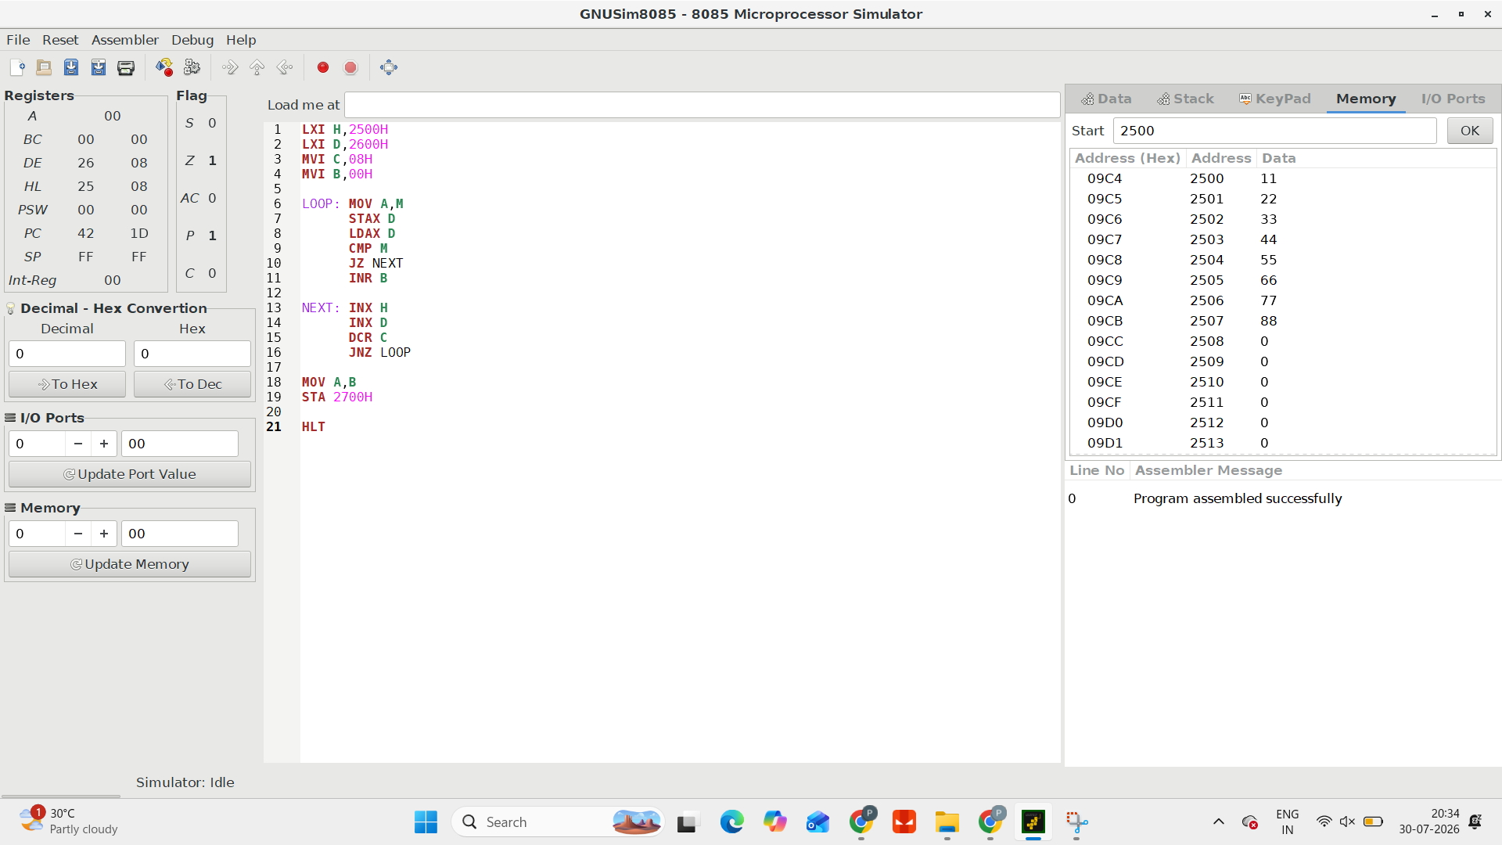

2. Copy 8 Bytes, Compare and Count Mismatches :
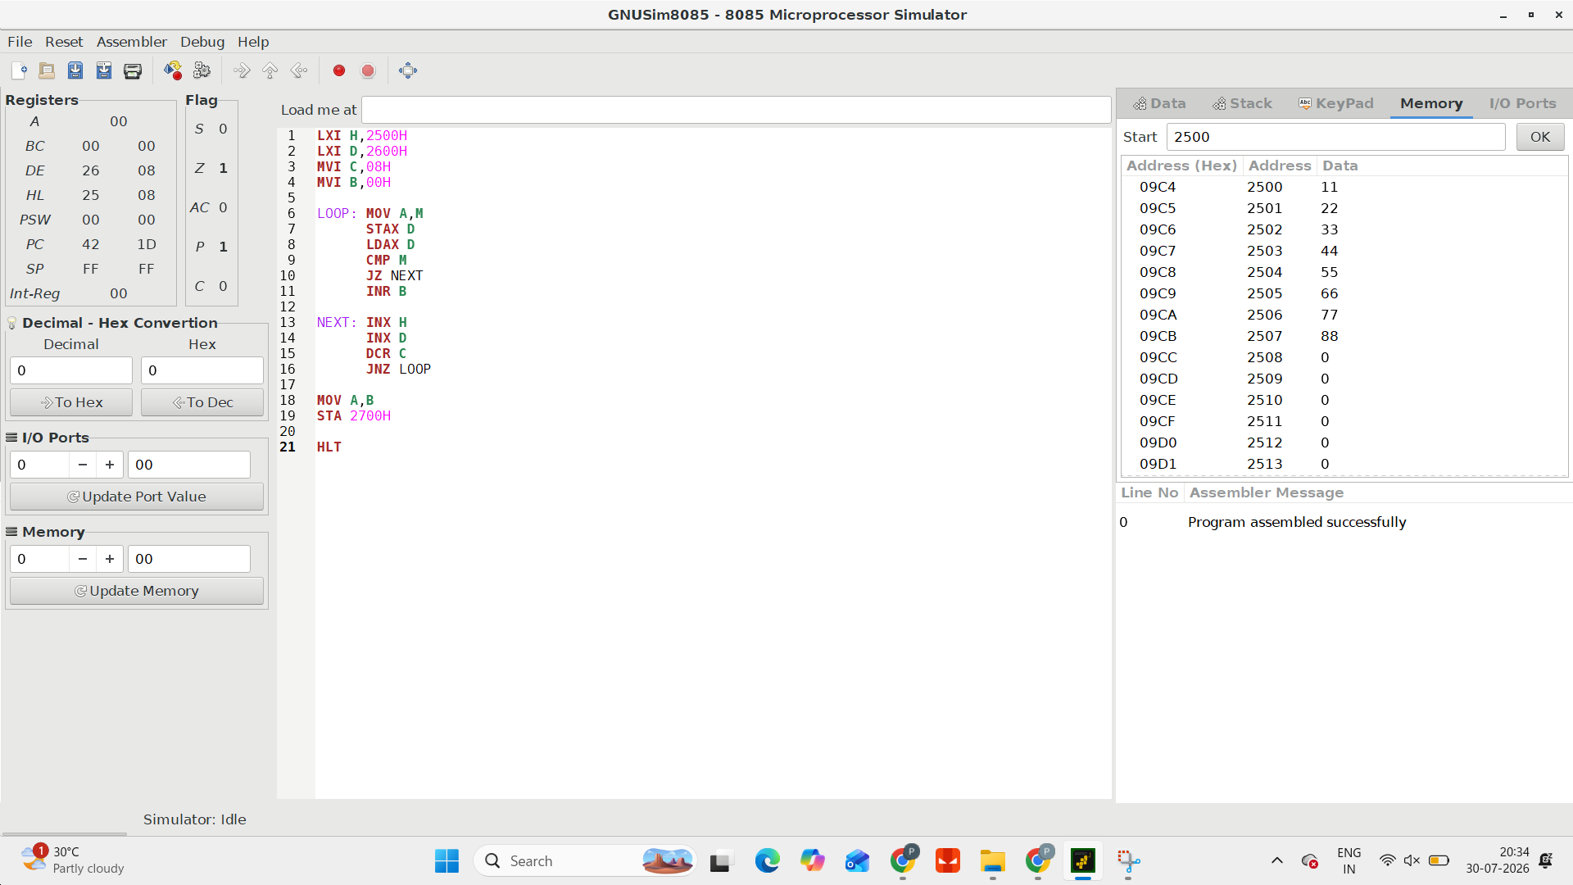

3. Count Set Bits and Check Even/Odd Parity :

